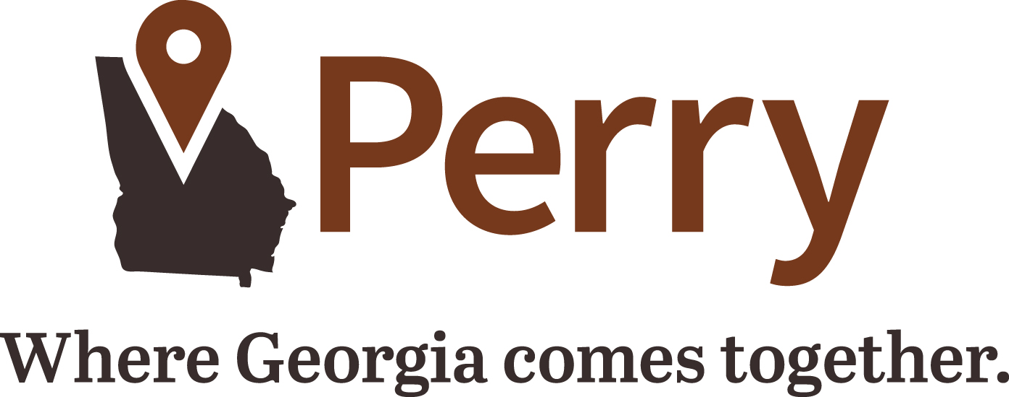

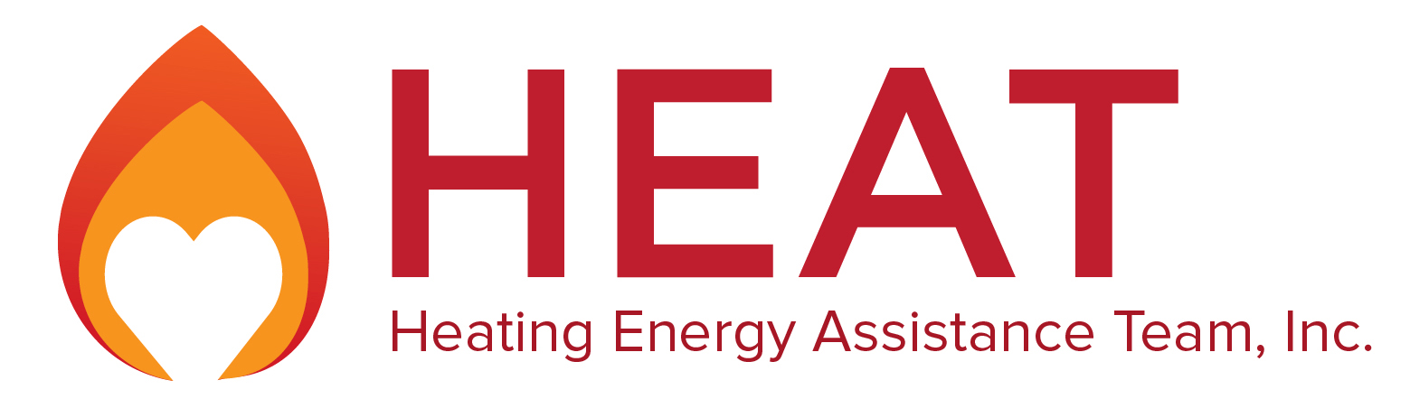

Help Your Neighbors by Donating to HEAT

In times like these, HEAT is ready to step up and help Georgia families get by, and we know that Perry is ready to do the same. With higher prices for items like food and gasoline, people with low or fixed incomes are in desperate need. Here in Perry, we’re committed to doing our part to help support those who are struggling to pay their utility bills during these difficult times. That’s why we’ve partnered with HEAT, a charity that’s been helping Georgians get back on their feet by assisting them with their heating bills for more than 40 years.

During the winter, many of us enjoy the comfort of a warm, cozy home. But thousands of Georgians must choose between paying their heating bills and buying other necessities like food or medication.

HEAT is the oldest statewide fuel fund in Georgia and provides energy assistance to thousands of vulnerable Georgians every year. HEAT has distributed more than $31 million to nearly 120,000 families since it began in 1983. Qualified households are able to receive help with heating bills regardless of the energy source – natural gas, propane, electricity, oil, wood, coal or any other energy source.

Many of the people who already relied on HEAT – the elderly, disabled, and veterans—are those who have been hit hardest by inflation. This year, many of them will find their fixed incomes will simply not allow them to make ends meet. This is why Perry has made it easy for you to help your neighbors by allowing you to make a tax-deductible contribution to HEAT directly on your utility bill.

Your contribution will help provide assistance for Georgians that will enable them to keep their heat on or restore service during a difficult time.

Here’s How You Can Help
- Make a donation through your City of Perry utility bill. Call 478-988-2754 to sign up.
- Make your donation (check or money order) payable to HEAT and mail it to:
HEAT
City of Perry
P.O. Box 230
Perry, GA 31069
- Donate online at heatga.org.

How Are HEAT Funds Distributed?
The Georgia Division of Family and Children Services distributes HEAT funds through local community action agencies. Qualified households apply for assistance at the agency that serves their county. Applicants must meet special guidelines established for HEAT that include income eligibility. Once an application is approved, a one-time assistance payment is awarded to prevent disconnection or restore service.

For more information or to see stories of some of the people we’ve helped, visit our website at www.heatga.org. You can also contact HEAT at 678-406-0212 or info@heatga.org.

Need Help With Your Heating Bill?
HEAT is proud to work locally with Middle Georgia Community Action Agency, Inc. (your local community action agency) to help potential recipients with the application process. Contact them by phone at 478-922-4464 or visit their website at mgcaa.org for more information on how to apply. The application period for the general public is usually December through the end of May.

